Program 1: Regular Expressions in Python
Aim: To match and search for patterns in text using regular expressions.
PROGRAM:
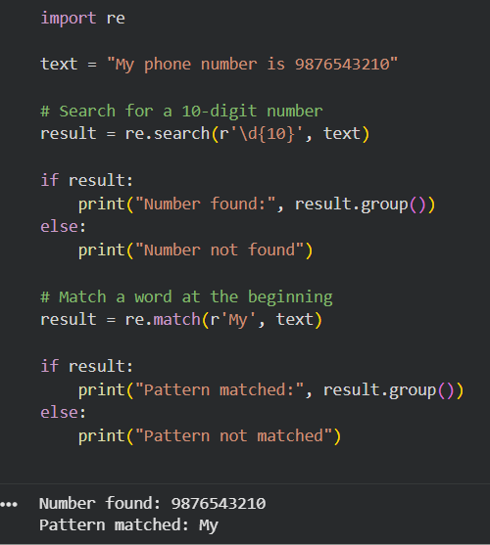
Program 2: Finite State Automaton — Strings Ending with ab
PROGRAM:

def accepts(text):
state = 0
for ch in text:
if state == 0:
if ch == 'a':
state = 1
else:
state = 0

elif state == 1:
if ch == 'a':
state = 1
elif ch == 'b':
state = 2
else:
state = 0
elif state == 2:
if ch == 'a':
state = 1
else:
state = 0
return state == 2
text = input("Enter a string: ")
if accepts(text):
print("String accepted")
else:
print("String rejected")
OUTPUT:


Program 3: Morphological Analysis Using NLTK
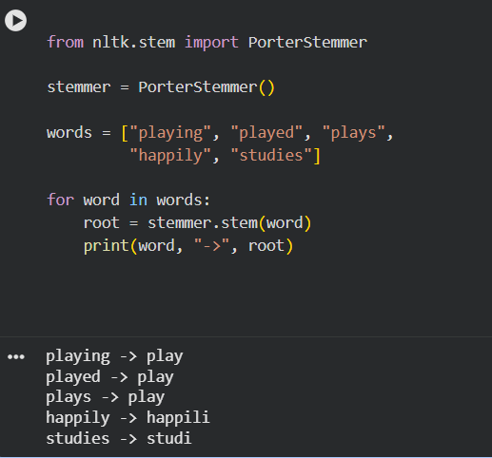

Program 4: Finite-State Machine for English Plural Formation
PROGRAM:
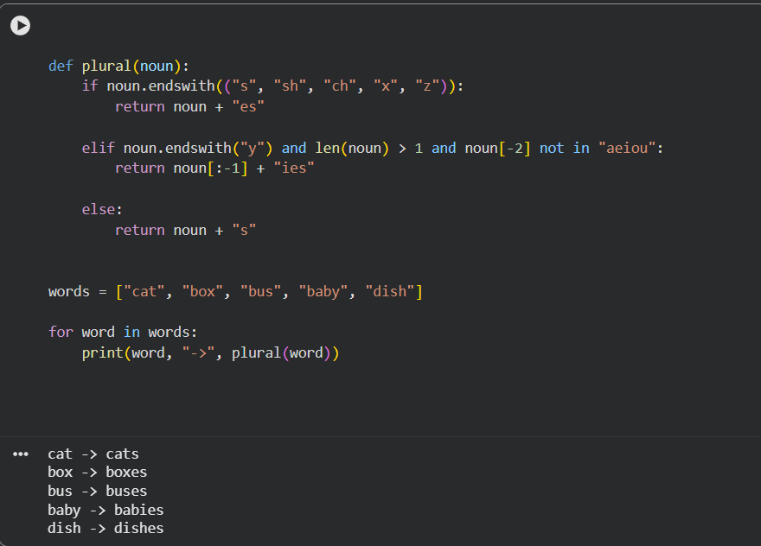

Program 5: Porter Stemmer Algorithm
OUTPUT:
